**Why Do Companies Need a Website and How it Helps to Improve Business?**

**Website:** Website is a place where businesses show their products and services digitally for customers. In a normal way everyone knows “A Collection of Web-Pages”.

A Web-Page holds content like Text, Images, Videos, Audios, Anchor Text & Links etc., which represents and explains, what current page relates.

Planning a website for your business means you are thinking of expanding your business globally and targeting to reach more customers through digital presence. Now a days, every business need website to reach more targeted audience and to grab market to earn profits.

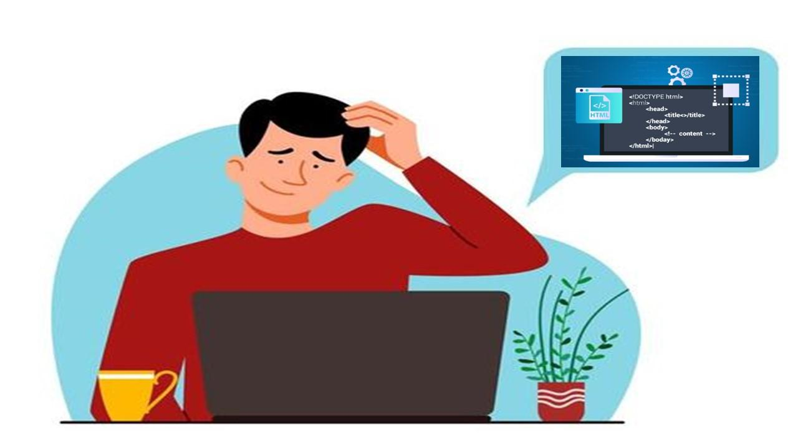

First of all, as a business owner, note down a few questions and search for answers.

* Website is must for Business? If yes, what kind of Website is needed for your business either Static or Dynamic.?
* What is your plan of action, if you have customers out of your region? How do you reach them with your unique products and services?

Any confusion in finding the difference between “What is Static Website and Dynamic Website?”- just Google you get more stuff about Website Design and Development, still not getting enough knowledge & clarity reach out to the  [**Web Design Company**](https://www.ymtsindia.com/website-development-services), share your ideas and ask your queries they will help you.

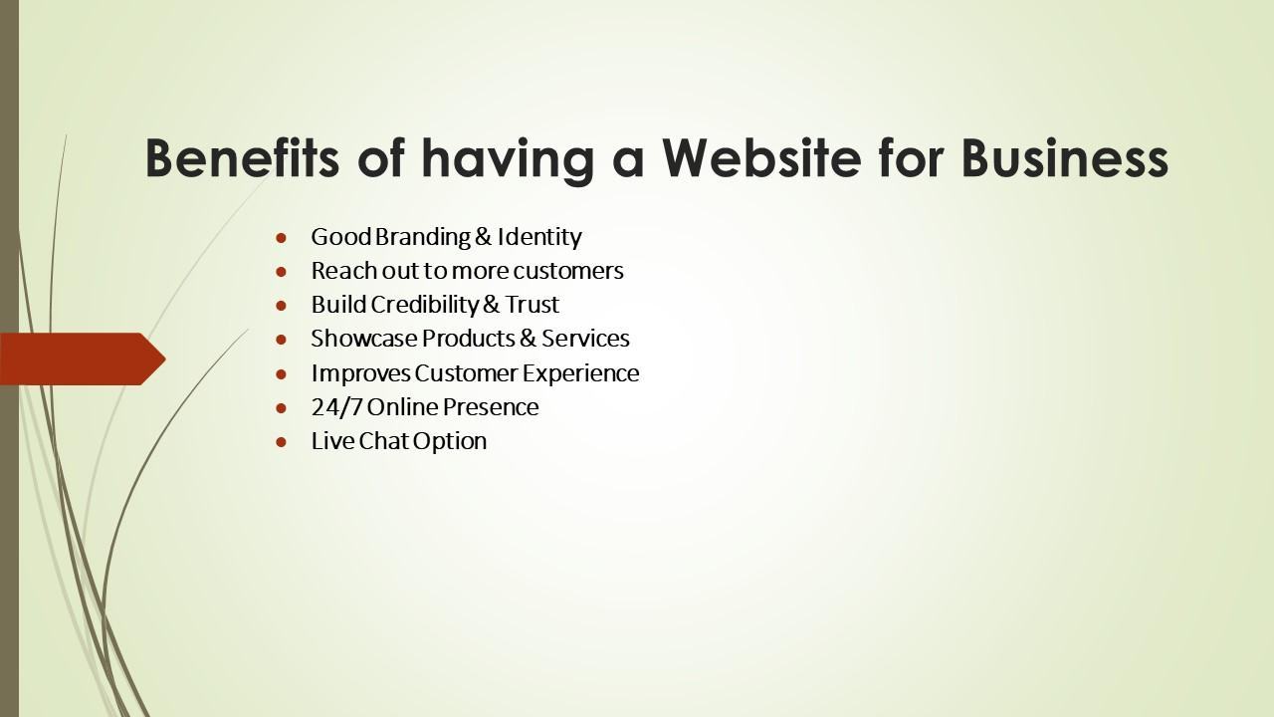

**Below few important points will let you know the “Benefits of a Website for Your Business”: -**

* **Good Branding & Identity: -** Your Brand Image to tell the world the right story. So, differentiate your business from others (competition in the market).
* **Reach out to more customers: -** When your website is [**Search Engine Optimized**](https://www.ymtsindia.com/digital-marketing-services), you'll have a better chance of driving potential customers.
* **Build Credibility & Trust: -** A Professional Website with Good Functionality and Error-free will create Credibility and Trust.
* **Showcase Products & Services: -** Through the website you can showcase your Products and Services visually with Explanation and Reviews.
* **Improves Customer Experience: -** Make Website as User Friendly, when visitors enter your site, they expect to find what they came there to find.
* **24/7 Online Presence: -** Not sure when customers reach you having a website digitally is always easy for customers to find you anytime, anywhere.
* **Live Chat Option: -** Live chat improves the support experience for customers and increases customer engagement.